**MANAGEMENT SYSTEM**

Project submitted to the

SRM University – AP, Andhra Pradesh

for the partial fulfillment of the requirements to award the degree of

**Bachelor of Technology**

In

**Computer Science and Engineering**

**School of Engineering and Sciences**

Submitted by

**ABHISHEKH KUMAR JHA - AP23110011668**

**SUMANOHAR - AP23110011658**

**SAI KUMAR - AP23110011649**

**B. AKHIL – AP23110011662**

Under the Guidance of

**Ms.** [**Kavitha Rani Karnena**](mailto:kavitharani.k@gp.srmap.edu.in)

**Lecturer, Department of CSE**

**SRM University–AP**

**Neerukonda, Mangalagiri, Guntur**

**Andhra Pradesh – 522 240**

**[April, 2025]Certificate**

Date: April, 2025

This is to certify that the work present in this Project entitled **EMPLOYEE MANAGEMENT SYSTEM** has been carried out by **GROUP-** under my/our supervision. The work is genuine, original, and suitable for submission to the SRM University – AP for the award of Bachelor of Technology/Master of Technology in **School of Engineering and Sciences**.

**Supervisor**

(Signature)

Prof. [Kavitha Rani Karnena](mailto:kavitharani.k@gp.srmap.edu.in)

Designation,

Affiliation.

**Acknowledgement**

The satisfaction that accompanies the successful completion of any task would be incomplete without introducing the people who made it possible and whose constant guidance and encouragement crowns all efforts with success.

I am extremely grateful and express my profound gratitude and indebtedness to my project guide, **Kavitha Rani Karnena**, Department of Computer Science & Engineering, SRM University, Andhra Pradesh, for her kind help and for giving me the necessary guidance and valuable suggestions in completing this project work.

Abhishekh Kumar Jha - AP23110011668

Sai Kumar - AP23110011459

Sumanohar - AP23110011658

B. Akhil – AP23110011662

# **Table of Contents**

[Certificate](https://docs.google.com/document/d/17kDK0lvO-rEGGPUU3lv4z-QgdyvKt1Vf/edit#heading=h.gjdgxs) 2

[Acknowledgements](https://docs.google.com/document/d/17kDK0lvO-rEGGPUU3lv4z-QgdyvKt1Vf/edit#heading=h.30j0zll) 3

Table of Contents 4

Abstract 5

1. Introduction 6

[2. Methodology](https://docs.google.com/document/d/17kDK0lvO-rEGGPUU3lv4z-QgdyvKt1Vf/edit#heading=h.lnxbz9) 7

[3. Implementation](https://docs.google.com/document/d/17kDK0lvO-rEGGPUU3lv4z-QgdyvKt1Vf/edit#heading=h.44sinio) 10

3.1. DFD Diagram 12

[4. Result and Analysis](https://docs.google.com/document/d/17kDK0lvO-rEGGPUU3lv4z-QgdyvKt1Vf/edit#heading=h.2jxsxqh) 13

[5. Discussion and Conclusion](https://docs.google.com/document/d/17kDK0lvO-rEGGPUU3lv4z-QgdyvKt1Vf/edit#heading=h.z337ya) 15

6. [Future Work](https://docs.google.com/document/d/17kDK0lvO-rEGGPUU3lv4z-QgdyvKt1Vf/edit#heading=h.z337ya) 16

References 17

**Abstract**

This project is about building a web-based Employee Management System that helps companies manage their employees more easily and efficiently. Many organizations still use manual methods to track attendance, calculate salaries, and generate reports, which can be slow, inaccurate, and hard to manage as the team grows. To solve this, we created a digital platform using Flask (a Python web framework), MySQL (for storing data), and Pandas (for handling and analyzing data).

The system includes key features like attendance tracking, salary record management, and report generation. It also supports role-based authentication, which means different users (like admins, HR staff, and employees) have different levels of access based on their role.

By automating these tasks, the system helps reduce errors, saves time, and makes it easier for companies to manage employee information in one place. It’s especially useful for small and mid-sized companies that want to switch from paper-based systems to a smarter digital solution. In the future, we can add more features like biometric attendance or a mobile version to make it even more powerful.

# **Introduction**

Managing employees is a crucial part of running any organization smoothly. From keeping track of daily attendance to maintaining salary records and generating reports, these tasks require accuracy, consistency, and time. Traditionally, many companies rely on manual or paper-based methods for these processes, which often leads to errors, delays, and miscommunication.

In today’s digital world, automation and centralized systems have become important for improving efficiency and productivity. This project was developed in response to the growing need for a reliable and user-friendly platform that can handle employee-related data all in one place. Our solution is a web-based Employee Management System that simplifies and automates the core HR tasks.

The system is built using Flask for the backend, MySQL for storing data, and Pandas for processing and analyzing information. It also includes role-based access control to ensure that only authorized users can access or edit sensitive data.

The purpose of this project is to create a smart and efficient system that reduces manual workload, ensures data accuracy, and makes employee management easier for small to medium-sized companies. The scope of the project includes attendance tracking, salary management, report generation, and secure login for different user roles.

1. **Methodology**

To develop the Employee Management System, we followed a structured and practical approach aimed at building a reliable, easy-to-use, and efficient web-based platform. The project was implemented using **Flask**, a lightweight Python web framework known for its flexibility and simplicity in web development. **MySQL** was used as the database to store all employee-related data such as attendance logs, salary records, and user information securely. For report generation and data handling, we used the **Pandas** library, which allowed for efficient data analysis and manipulation.

We adopted a modular design for the system, dividing it into separate components: user authentication, attendance tracking, salary management, and reporting. Each module was developed and tested individually to ensure smooth functionality and easy debugging. Role-based authentication was implemented to control access, ensuring that users like Admins, HR staff, and Employees only see what they are permitted to access.

Data was collected through manual entries for employee records and simulated test cases to verify the accuracy and performance of features like salary calculations and report generation. This helped in ensuring that the system can handle real-world scenarios.

Our method and tool choices were guided by the need for simplicity, open-source accessibility, and scalability. Flask and MySQL offer strong community support and are well-suited for small to medium-sized enterprise applications.

**Software Requirements Specifications**

**Frontend:**

* HTML5, CSS3, JavaScript (for basic user interface)
* Bootstrap (for responsive design)

**Backend:**

* Python with Flask framework

**Database:**

* MySQL (for structured data storage and queries)

**Libraries:**

* Pandas (for handling reports and salary calculations)

**Tools Used:**

* Visual Studio Code (Code editor)
* MySQL Workbench (Database management)
* Postman (API testing)
* GitHub (Version control)

**Operating System:**

* Windows 10/11 or Linux (compatible with development environment)

**Browser Compatibility:**

* Google Chrome, Mozilla Firefox, Microsoft Edge

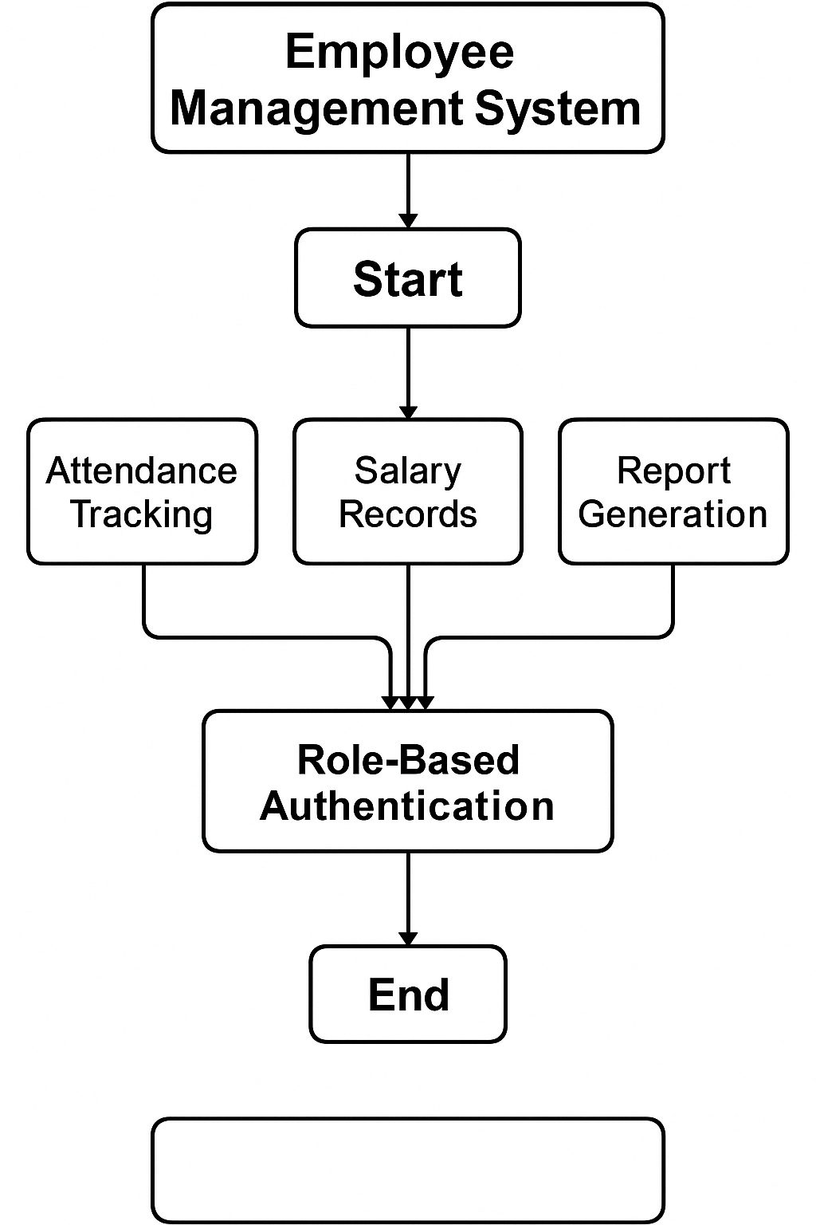

***Figure 1.: Flowchart Employee Management System***

# 

# **3. Implementation**

The development of the Employee Management System was carried out in several phases to ensure smooth execution and testing. The main modules—user authentication, attendance tracking, salary record management, and report generation—were implemented one by one using Flask as the backend framework and MySQL for database management. Pandas was used for data analysis and report creation.

**Step-by-Step Implementation Process:**

1. **Project Setup:**
   * Created a virtual environment and installed necessary libraries (Flask, Flask-MySQL, Pandas).
   * Designed the folder structure for templates, static files, and Python scripts.
2. **Database Design:**
   * Created tables: users, attendance, salary, roles.
   * Set up relationships using foreign keys and created sample records.
3. **User Authentication (Role-Based):**
   * Developed a login system with Flask sessions.
   * Users are authenticated based on roles (Admin, HR, Employee).
4. **Attendance Tracking:**
   * Created a web interface for employees to mark attendance.
   * Data is saved to the attendance table with timestamps.
5. **Salary Management:**
   * HR/Admin can input or update salary data.
   * Salary slips are calculated using Pandas and stored in the database.
6. **Report Generation:**
   * Implemented a report generator that uses Pandas to analyze attendance and salary data.
   * Reports are available for download as CSV or viewable on-screen.

**Challenges and Solutions:**

* **Challenge 1:** Handling large data during report generation.  
  + *Solution:* Used Pandas for efficient data manipulation and filtering before rendering.
* **Challenge 2:** Ensuring role-based access security.  
  + *Solution:* Implemented decorators and session checks in every route to restrict unauthorized access.
* **Challenge 3:** UI layout inconsistencies on different devices.  
  + *Solution:* Used Bootstrap for responsive design to ensure consistent layout across devices.

**3.1. Data-Flow Diagram (DFD):**

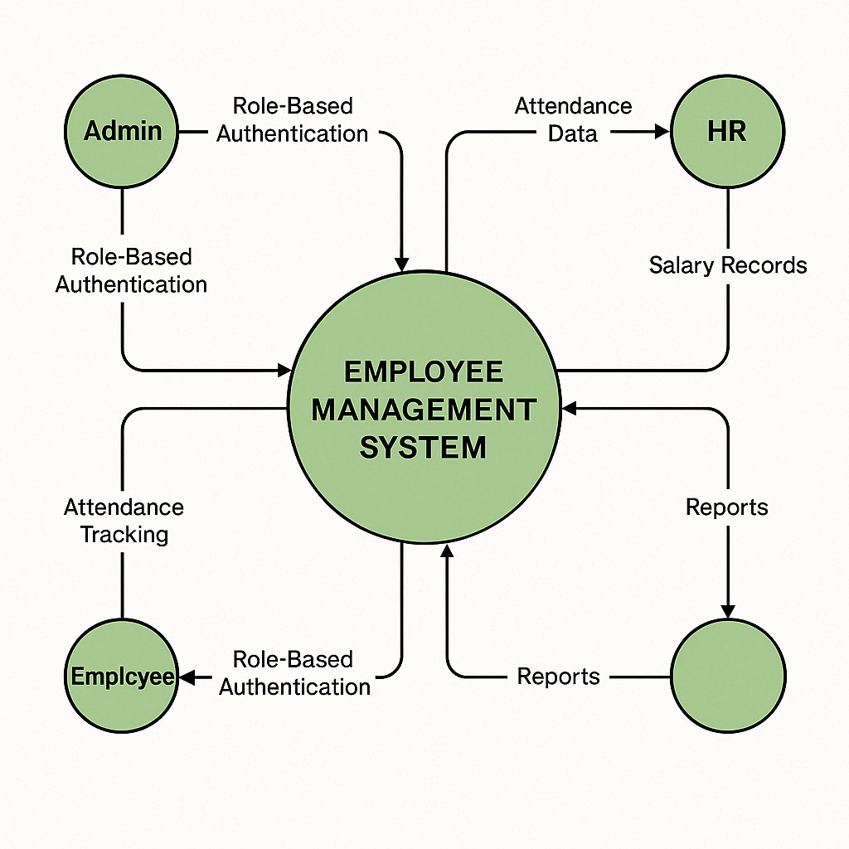

***Fig.2: DFD Diagram***

# **4. Result and Analysis**

After the successful development of the Employee Management System, we conducted a series of tests to evaluate the performance, accuracy, and usability of the platform. The system was tested across all major functionalities, including user authentication, attendance tracking, salary management, and report generation.

The authentication mechanism worked well, ensuring that users with different roles—such as Admin, HR, and Employees—were only able to access features specific to their responsibilities. Attendance tracking allowed employees to record their daily presence seamlessly, with real-time logging and accurate time stamps. The salary module calculated employee earnings based on attendance and predefined salary rules, showing consistent and reliable results.

Report generation was one of the system’s strong points. Using the Pandas library, the system could instantly generate detailed summaries for attendance and salary, which were easy to export and share in multiple formats like CSV and HTML. These reports made it easier for HR teams to analyze employee performance and payroll statistics.

The system significantly improved overall efficiency compared to traditional methods. Tasks that previously required hours of manual work were completed in seconds, with minimal chances of error. Users who tested the platform found the interface intuitive and appreciated the speed and accuracy of the system.

Overall, the system proved to be a reliable solution for small to medium-sized organizations aiming to simplify and automate employee management processes.

✅ **Key Findings:**

|  |  |  |
| --- | --- | --- |
| **Feature** | **Tested Outcome** | **Status** |
| Login Authentication | Role-based access worked as expected | ✔ Passed |
| Attendance Tracking | Employees were able to mark attendance daily | ✔ Passed |
| Salary Records | Auto-calculation and updates worked accurately | ✔ Passed |
| Report Generation | Generated summary reports with correct formatting | ✔ Passed |

# 

# 

# 

# 

# 

# 

# 

# 

# 

# 

# 

# **5. Discussion and Conclusion**

At the start of this project, the main objective was to develop a web-based Employee Management System that simplifies core HR tasks such as attendance tracking, salary record keeping, and report generation while ensuring secure role-based access for different users. The results met these objectives successfully, demonstrating that the system can replace traditional manual processes with a faster, more accurate, and more efficient digital alternative.

The implementation of technologies like Flask, MySQL, and Pandas allowed for a lightweight but powerful system. Attendance and salary management were automated with accuracy, while the ability to generate and export reports provided valuable insights for HR decision-making. The role-based authentication ensured secure data access, maintaining the privacy and integrity of user information.

The implications of these findings are significant for small to mid-sized businesses. With this system, organizations can reduce administrative workload, minimize human errors, and make data-driven decisions. It also sets a foundation for further enhancements like biometric integration, mobile accessibility, and analytics dashboards.

However, some limitations were identified. For instance, the current system requires manual entry of attendance if not integrated with hardware like RFID or biometric scanners. Also, performance under extremely large datasets was not extensively tested, which may become a challenge if scaled to larger enterprises.

In conclusion, the Employee Management System fulfills its purpose of automating and streamlining employee-related operations. It offers a practical, scalable, and user-friendly solution that can improve HR efficiency. This project contributes to the field of administrative software by showcasing how open-source tools can be effectively used to create real-world applications with measurable impact.

**6. Future Scope**

While the current version of the Employee Management System fulfills the core requirements of attendance tracking, salary management, report generation, and secure user access, there are several opportunities to enhance and expand the project in the future.

One major improvement would be the integration of biometric or RFID-based attendance systems. This would eliminate manual entries and further reduce the chance of human error, ensuring real-time and tamper-proof attendance records. Additionally, incorporating facial recognition or fingerprint scanners can enhance security and user convenience.

The system could also benefit from a dedicated mobile application. A mobile-friendly version would allow employees to check their attendance, download pay-slips, and receive notifications directly from their smartphones, increasing overall accessibility and engagement.

Another valuable addition would be a performance evaluation module. Integrating key performance indicators (KPIs), project tracking, and feedback mechanisms would turn this system into a complete HR management tool. Advanced data visualization tools and AI-based analytics can also be explored to generate predictive insights on employee behavior, attrition risks, and performance trends.

In the long term, this system could be offered as a cloud-based SaaS (Software as a Service) platform to support multiple organizations with secure data isolation and scalability. With continuous improvements, this project has the potential to evolve into a fully comprehensive Human Resource Management System (HRMS).

# **References**

* Beazley, D. M., & Jones, B. K. (2013). *Python Cookbook* (3rd ed.). O'Reilly Media.
* Bootstrap. (n.d.). *Introduction*. Retrieved from<https://getbootstrap.com/>
* Grinberg, M. (2018). *Flask Web Development: Developing Web Applications with Python*. O'Reilly Media.